**Exercises 1**

1. Create a variable named counter and set it equal to 0.
2. Create a while loop with the condition counter < 10.
3. The loop body should print out “counter is X” (where X is replaced with the value of counter) and then increment counter by 1.

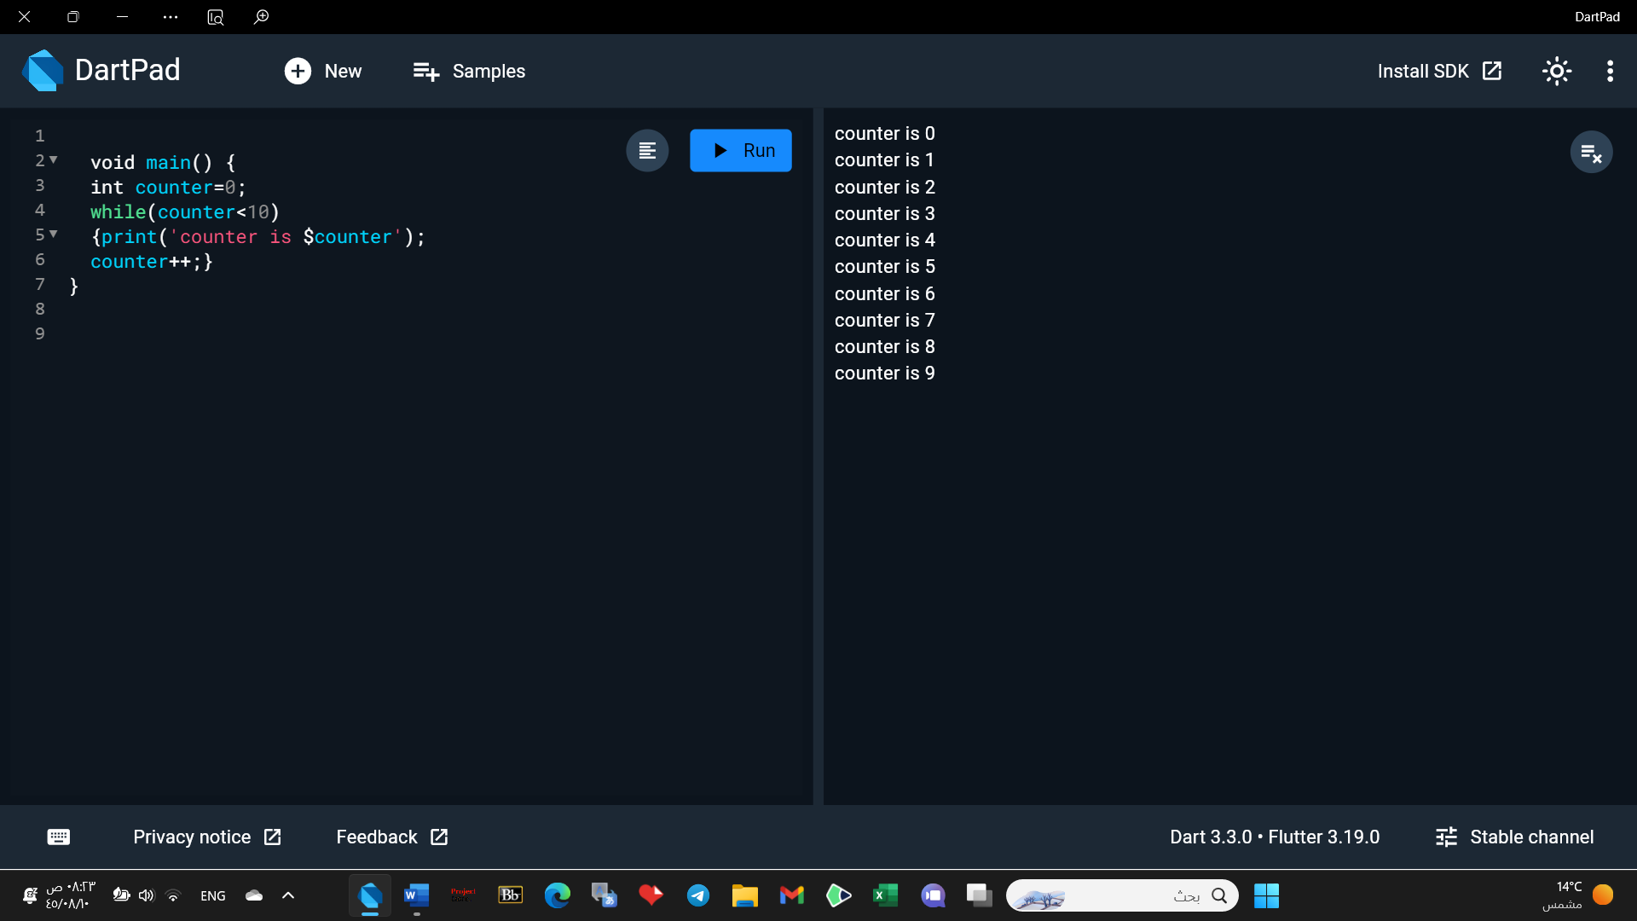**Exercises 2**

1. Write a for loop starting at 1 and ending with 10 inclusive.
2. Use the loop to print only the square of the odd number.

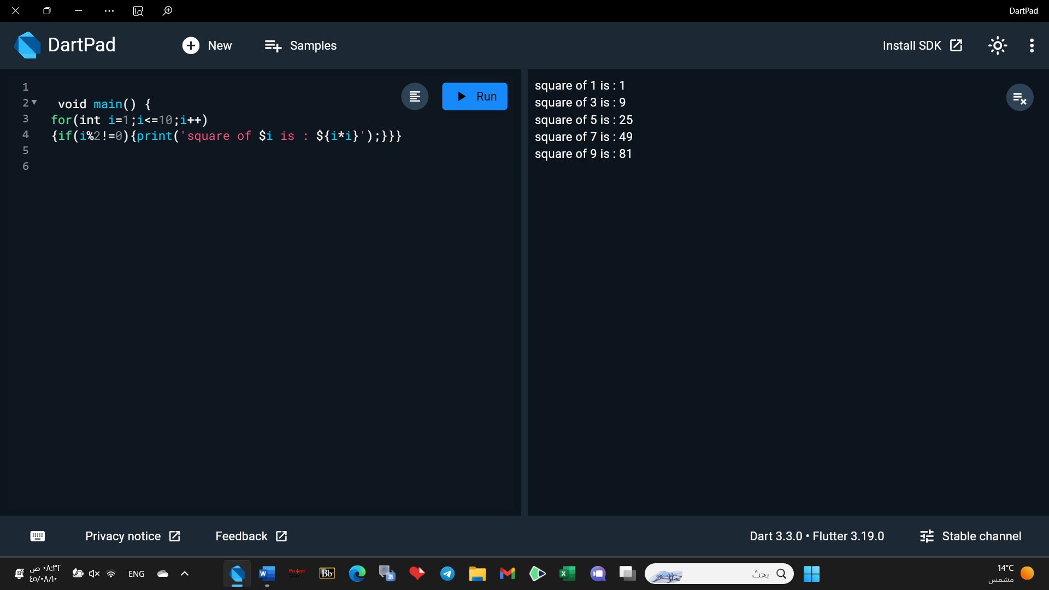

**Exercises 3**

1. Write a function named youAreWonderful, with a string parameter called name.

It should return a string using name, and say something like “You’re wonderful,

Bob.”

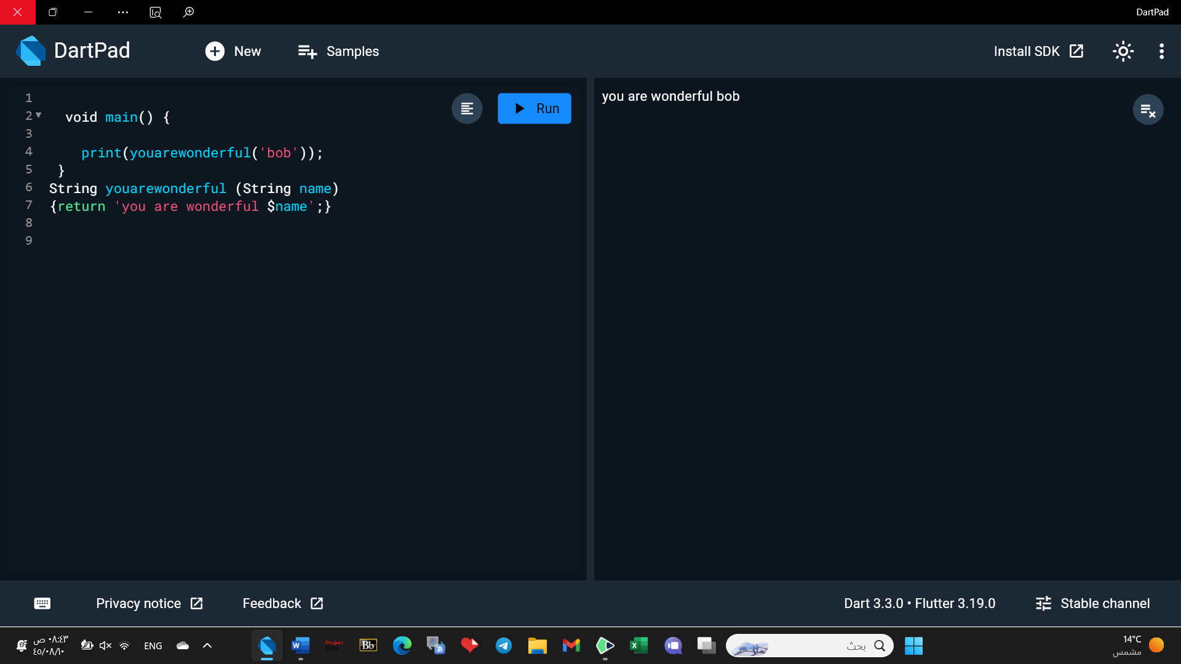

2. Add another int parameter to that function called numberPeople so that the

function returns something like “You’re wonderful, Bob. 10 people think so.”

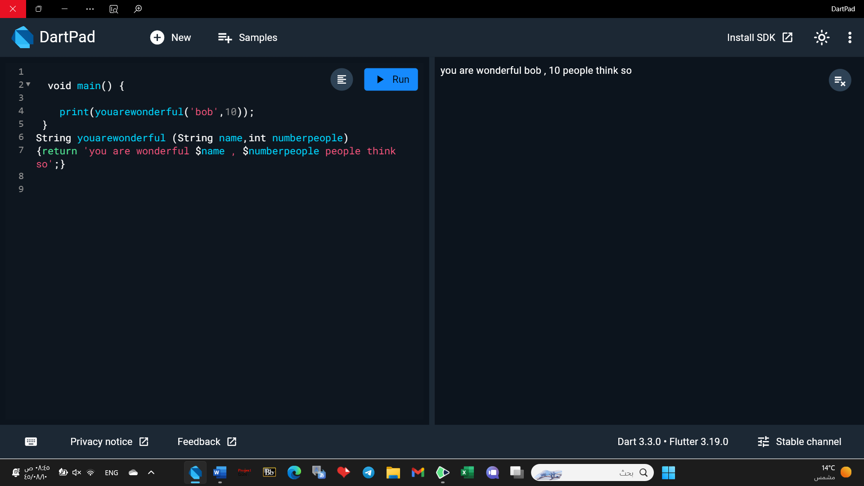

3. Make both inputs named parameters. Make name required and set numberPeople

to have a default of 30..

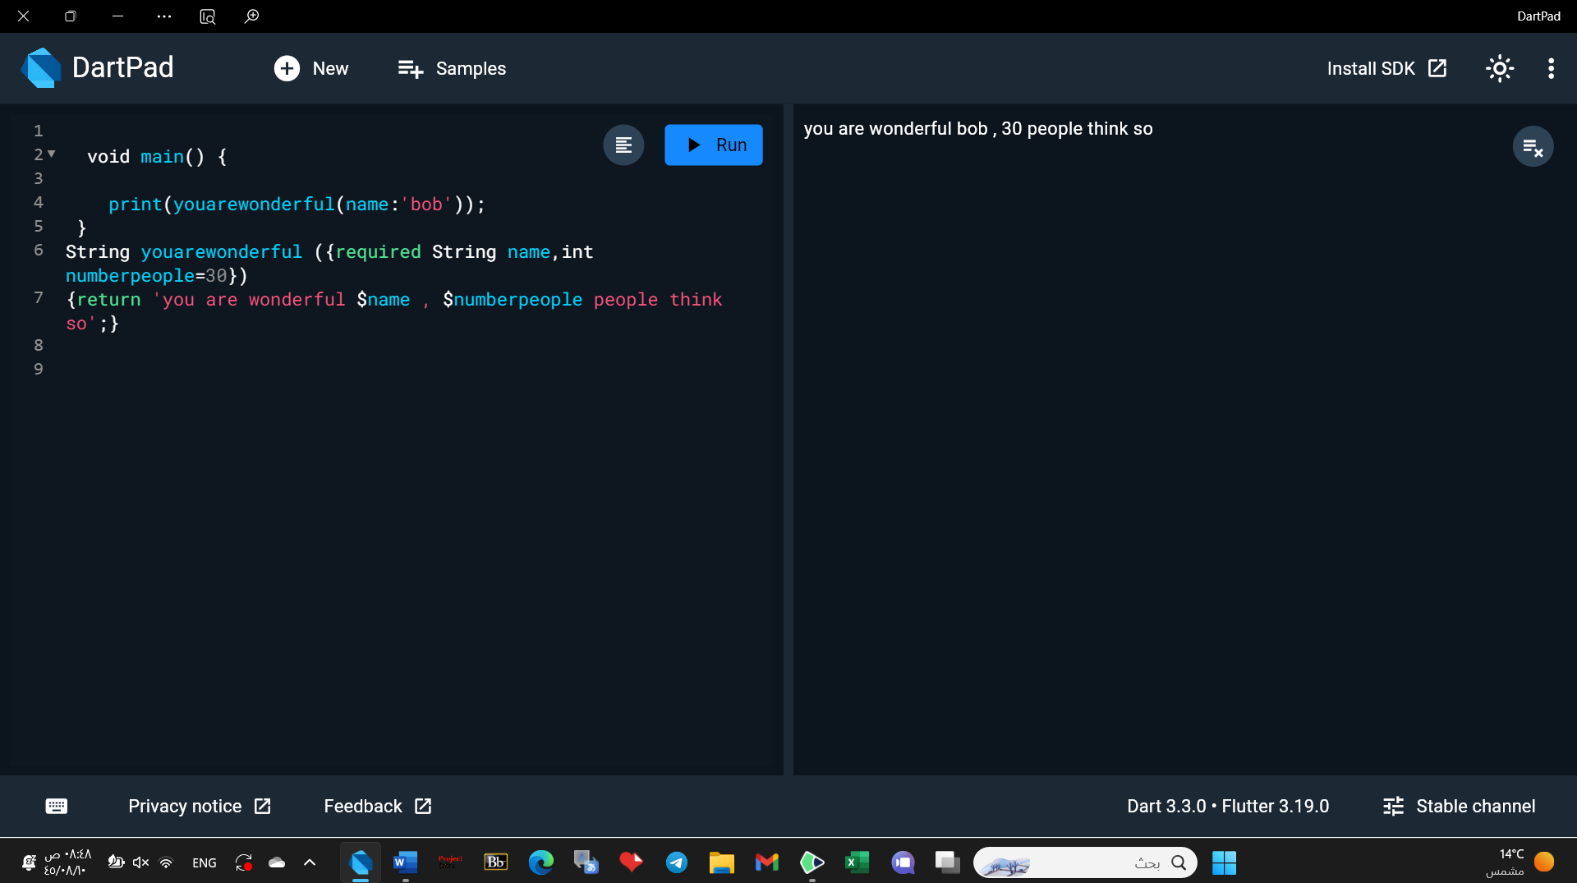

Exercise 4:

Start with the following list of numbers:

const numbers = [1, 2, 4, 7];

Print the square of each number: 1, 4, 16 and 49.

1. First, use a for loop.

2. Solve the problem again using a for-in loop.

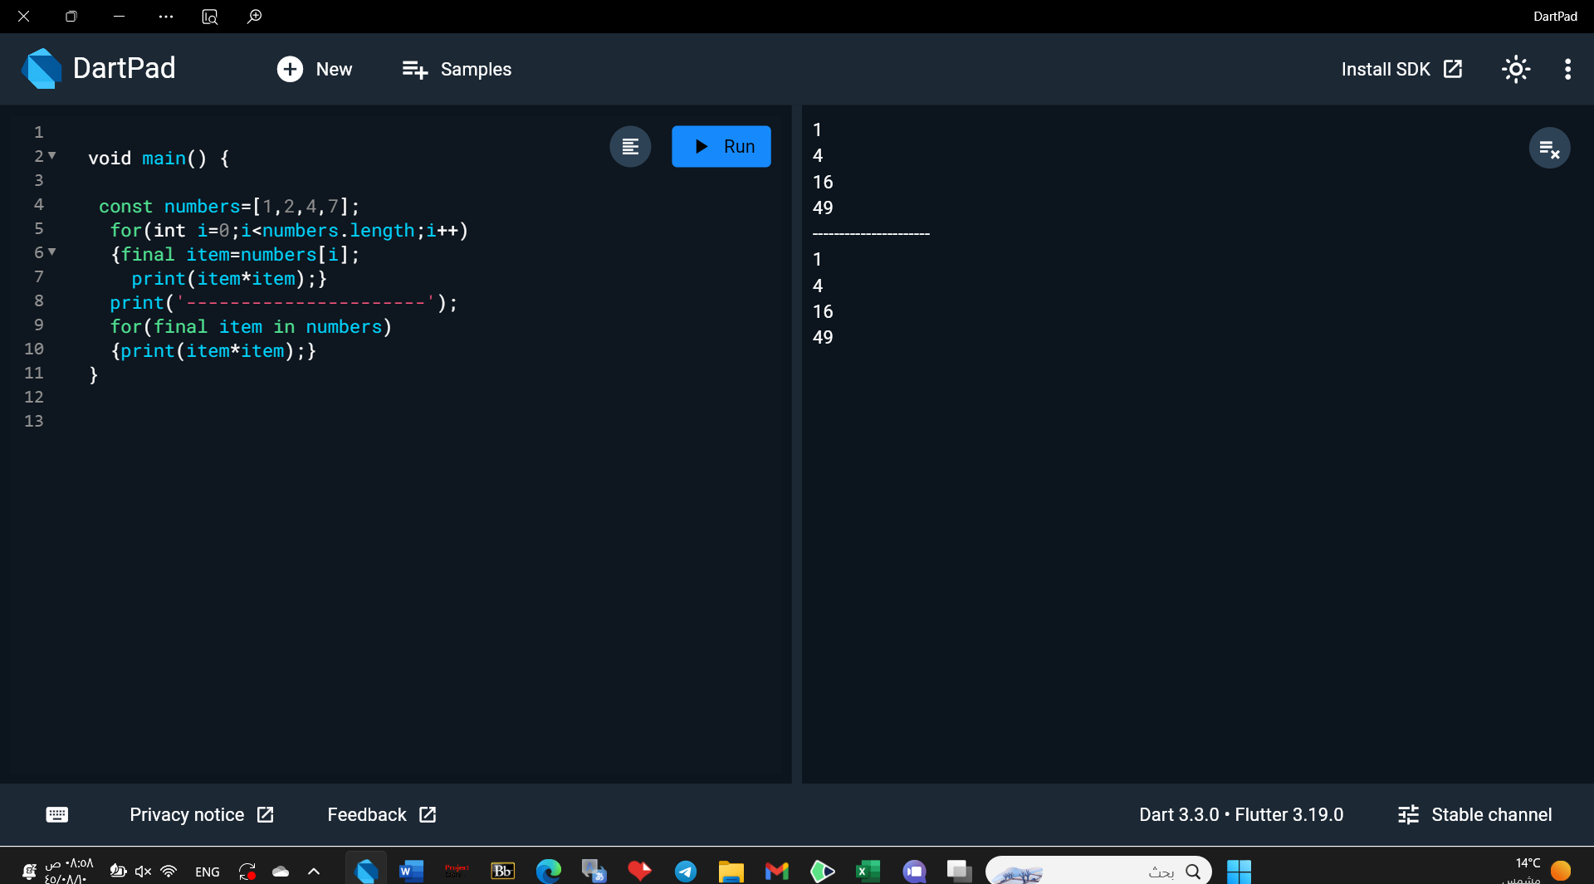

Exercise 5:

Write a code to combine list1 and only the even numbers of list2. Print the out put.

list1=[12, 4,5,8,1]

list2=[2, 3,4,5,6,7]

